Atenção ERRATA: os Links de bateria do SAMBA AVANÇADO estão nos links 860 até 868
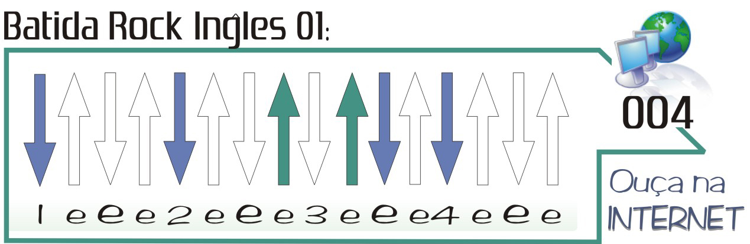
http://www.youtube.com/watch?v=Y0BvVVi20nQ

(Nesta música use esta batida para cada DOIS acordes) How does it feel Avril Lavigne

Am C F C
im not afraid of anything i just need to know that i can breathe
Am C F %
and i dont need much of anything but suddenly suddenly

Am C F C
i am small and the world is big all around me is fast moving
Am C F %
surrounded by so many things but suddenly suddenly

C G F G
how does it feel to be different from me are we the same (- 18 28 -)
C G F G Am C F C
how does it feel to be different from me are we the same how does it feel

Am C F C
i am young and i am free but i get tired and i get weak
Am C F %
i get lost and i cant sleep but suddenly suddenly
C G F G
how does it feel to be different from me are we the same
C G F G Am Am
how does it feel to be different from me are we the same how does it feel

Am C G D Am C G D
would u comfort me ya ya ya would u cry with me ya ya ya ya
Am C G D Am C G D
uh uh uh..... uh uh uh.....

(só violão , passadão)
Am C Am C
i am small and the world is big but im not a afraid of anything

C G F G
how does it feel to be different from me are we the same
C G F G Am
how does it feel to be different from me are we the same how does it feel C G F G
how does it feel to be different from me are we the same
C G F G Am (fim)
how does it feel to be different from me are we the same how does it feel

