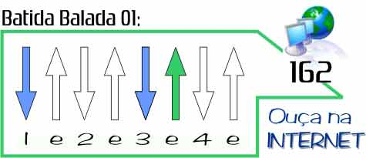
Para violão , pode ser tocada com balada básica

Fly away Lenny Kavitz
http://www.youtube.com/watch?v=cJMeTmdfNWk
Am C G D
I wish that I could fly Into the sky So very high
Am C G D
Just like a dragonfly
Am C G D
I'd fly above the trees Over the seas in all degrees
Am C G D
To anywhere I please
Am C G D Am C G D
Oh I want to get away I want to fly away Yeah yeah yeah
Am C G D
Let's go and see the stars The milky way or even Mars
Am C G D
Where it could just be ours
Am C G D
Let's fade into the sun Let your spirit fly Where we are one
Am C G D
Just for a little fun Oh oh oh yeah !
Am C G D Am C G D
Oh I want to get away I want to fly away Yeah yeah yeah
(--falado---) I got to get away Feel I got to get away
Am C G D
Oh oh oh yeah
Am C G D
I want to get away I want to fly away
Am C G D
Yeah with you yeah yeah Oh Yeah !

