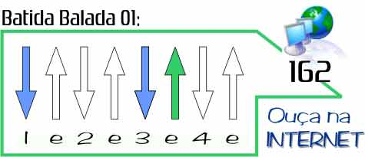

Behind Blue eyes (simplificada)

http://www.youtube.com/watch?v=qrFwtlMd0H8

Intro: Em G D D C C A A / Em G D C A A (arpejo)

Em G D % C % A %
No one knows what it´s like To be the bad man To be the sad man Behind blue eyes
Em G D % C % A %
No one knows what it´s like To be hated To be fated To telling only lies
C D G %
But my dreams They aren´t as empty
C D E %
As my conscience seems to be
D* % C % D % A % % %
I have hours, only lonely My love is vengeance That´s never free

Em G D % C % A %
No one knows what it´s like To feel these feelings Like I do And I blame you
Em G D % C % A %
No one bites back as hard On their anger None of my pain and woe Can show through

C D G %
But my dreams They aren´t as empty
C D E %
As my conscience seems to be
D* % C % D % A % % %
I have hours, only lonely My love is vengeance That´s never free

Solo ( no lugar do “falado”) Em----G D C A Em----G D C A

Em G D % C % A %
Well I know what is like To be mistreated To be defeated Behind blue eyes
Em G D % C % A %
No one knows how to say That they're sorry And don't worry I am not telling lies
C D G %
But my dreams They aren´t as empty
C D E %
As my conscience seems to be
D* % C % D % A % % %
I have hours, only lonely My love is vengeance That´s never free

Em G D % C % A %
No one knows what it´s like To be the bad man To be the sad man Behind blue eyes...

Observação “Mais que Música”:

D* - Está “simplificado. Na verdade seria um Bm. Você pode tentar fazer um Bm7 (x20232)

