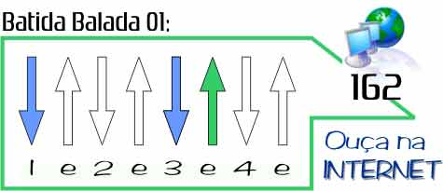
ou Dedilhado direto para uma versão mais leve
Apologize
(Timberland)
http://www.youtube.com/watch?v=74VG_6HhVKg

Em C G D
I'm holding on your rope, Got me ten feet off the ground

Em C G D
I'm hearin what you say but I just can't make a sound
Em C G D
You tell me that you need me Then you go and cut me down, but wait
Em C G D
You tell me that you're sorry Didn't think I'd turn around, and say...

Em C G D
It's too late to apologize, it's too late
Em C G D
I said it's too late to apologize, it's too late

Em C G D
I'd take another chance, take a fall Take a shot for you
Em C G D
And I need you like a heart needs a beat But it's nothin new
Em C G D
I loved you with a fire red- Now it's turning blue, and you say...
Em C G D
"Sorry" like the angel heaven let me think was you But I'm afraid...

Em C G D
It's too late to apologize, it's too late
Em C G D
I said it's too late to apologize, it's too late

( Em C G D ) 2x

Em C G D
It's too late to apologize, it's too late
Em C G D
I said it's too late to apologize, it's too late
Em C G
I'm holdin on your rope, got me ten feet off the ground...

