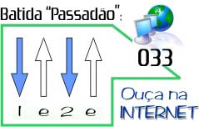

Let it be

Beatles
http://www.youtube.com/watch?v=YBPFvp750sc

G D Em C
When I find myself in times of trouble Mother Mary comes to me
G D C G
Speaking words of wisdom, let it be
G D Em C
And in my hour of darkness She is standing right in front of me
G D C G
Speaking words of wisdom, let it be

Em D C G
Let it be, let it be, let it be, let it be
G D C G
Whisper words of wisdom, let it be.

G D Em C
And when the broken-hearted people Living in the world agree
G D C G
There will be an answer, let it be
G D Em C
For though they may be parted There is still a chance that they will see
G D C G
There will be an answer, let it be

Em D C G
Let it be, let it be, let it be, let it be
G D C G
Whisper words of wisdom, let it be.

G D Em C
And when the night is cloudy There is still a light that shines on me
G D C G
Shine until tomorrow, let it be
G D Em C
I wake up to the sound of music Mother Mary comforts me
G D C G
Speaking words of wisdom, let it be
